5.1 Vector Fields

Up to this point in MTH 202 we have studied functions of the form and . In this final chapter of MTH 202 we turn our focus to the most general situation. Namely we will study functions of the form .

Definition:
- Let D be a set in . A vector field on is a function F that assigns to each point in D a two-dimensional vector .
- Let E be a set in . A vector field on is a function F that assigns to each point in E a three-dimensional vector .

Example 1: Use a picture to illustrate the vector field .

In order to sketch a picture of this vector field, we plug points into F. Then we draw the vector that F spits out on the xy-plane with initial point .

So, we note that:

Now, a picture illustrating F is:
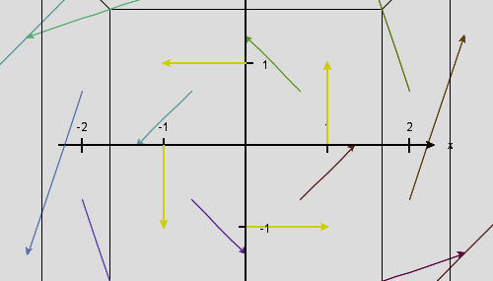
Remark: Vector fields have a wide variety of applications. For example, a vector field on can be used to model the amount of force exerted by an electric charge on some charge located at the point on a two dimensional plate.

A vector field on can be used to model the force of the wind at some point in space.

A vector field on can be used to model the current of the ocean at some point in the ocean.

A vector field on can be used to model the force due to gravity at some point in space.

A vector field in can be used to model the velocity of a moving fluid at some point in space.

Example 2: The gravitational force from an object of mass M centered at the origin acting on a small object of mass m at is where G is the universal gravitational constant.

Suppose a large three dimensional object has center of mass at the origin and has mass equal to 100,000 kg. Suppose a small object of mass 5 kg is located at the terminal point of the position vector (you may assume distance is in meters). What is the gravitational force acting on the small object (due to the large object)?

It is The unit on this force would be in Newtons.

Note: Since , we see that the force calculated in the above example is quite small.

Definition: If is a scalar function of two or three variables, is called the gradient vector field of f.

Definition: A vector field F is called a conservative vector field if it is the gradient of some scalar function . Mathematically, this means there must exist a scalar function so that . In this situation is called a potential function for F.

Example 3: Prove that is a conservative vector field.

Consider the scalar function . We note that . Thus, is a conservative vector field by definition.

Question: Is the only scalar function that would have worked in the above proof?

Note: For now, the only technique we have for proving a vector field is conservative is to guess and check until we successfully find a potential function for the vector field. We will develop more sophisticated techniques as in section 5.3.

Note: Right now, we do not have ANY technique for proving that a vector field is not conservative. We will develop techniques for proving a vector field is not conservative in section 5.3.

Example 4: Consider .

- Find the gradient vector field of f.

It is .

- Is the vector field you found in (a) conservative? Explain.

Yes, it is conservative because it is the gradient of the scalar function .

Note: Later in chapter 5 we will discover that conservative vector fields have some very nice properties.

